|  |
| --- |
| COMP3064 |
| Assignment One |
| External Documentation |

|  |
| --- |
| Mark Jerome Villamor  20-10-2017 |

Contents

Game Description 2

Controls Description 2

Interface Sketch 2

Screen Descriptions 2

Enemies 4

Scoring 4

Sound Index 5

Art/Multimedia Index 5

# Game Description

Player likes frogs so much she even has a frog hairpin. Guide her and hit as many frogs as possible to get scores. Avoid the rocks to survive so your life won’t reduce. Game is over once your life reaches zero.

# Controls Description

Player can be controlled by using either WASD or arrow keys. W to move up; A to move left; S to move down; and D to move right.

# Interface Sketch

# Screen Descriptions

Start State

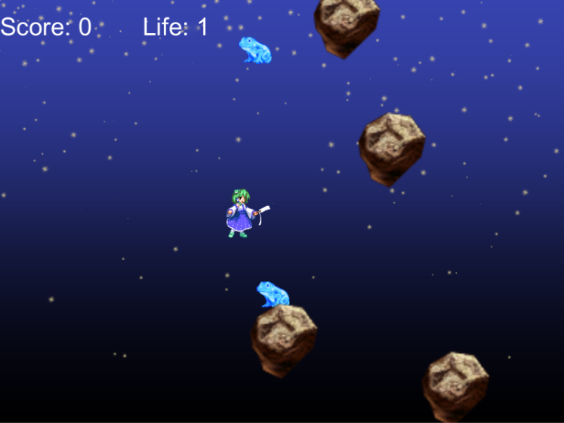Gameplay State

Game Over State

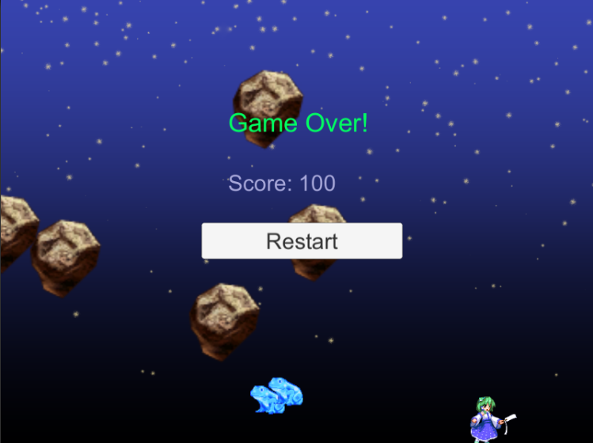

# Enemies

The enemies in the game are the rocks. Enemies spawn at random. At first there are only two rocks; but as time goes on, the rocks increase in order to provide challenge to the player.

# Scoring

Each frog counts as 100 points. Players must collide with frogs to get a score. For each frog the player collides, they will receive 100 points.

# Sound Index



Background Music Frog Sound

# Art/Multimedia Index

 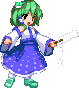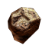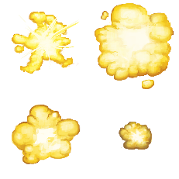

Frog Avatar Rock Explosion